Clan Gregor Society – Great Lakes Chapter
Scholarship Program Objectives
The Clan Gregor Society Great Lakes Chapter Scholarship Program is designed to help sponsor and assist persons pursuing education, training, and interests in Scottish arts, history, and/or culture.
The Program provides financial assistance to students to help offset the cost of education or training. Examples of eligible educational/training courses include instruction in Highland dancing, piping, drumming, fiddling, harp, Scottish American history, and Gaelic language. The program does not provide grants for non-educational, non-training activities, such as travel to and attendance at public events or performances.
Amounts: Scholarships may be awarded in varying amounts up to $200.
Eligibility: Applicants to the Scholarship Program must meet the following criteria:
- Be from age 12 to 24 at time of application, other applications may be accepted on a case by case basis at the discretion of the Chapter Council. Be a resident of the Clan Gregor Society Great Lakes Chapter region.
- Have demonstrated through past participation in Scottish-oriented activities a genuine interest in fostering and maintaining Scottish culture. However, past participation in Scottish-oriented activities need not be in the field for which the scholarship is being requested. For example, an applicant need not have previously had instruction in piping to apply for a piping scholarship.

Highland dancing is just one example of Scottish cultural arts. We include piping, drumming, history, and language among the fields of study supported.

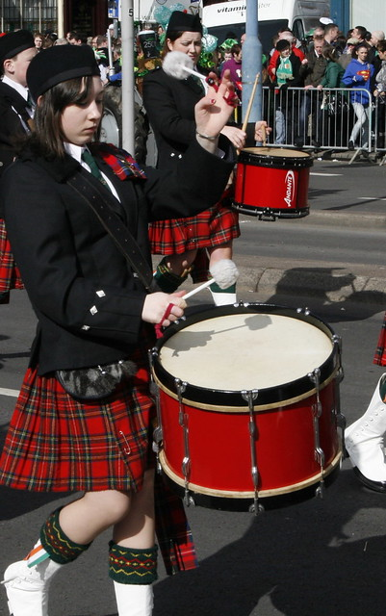
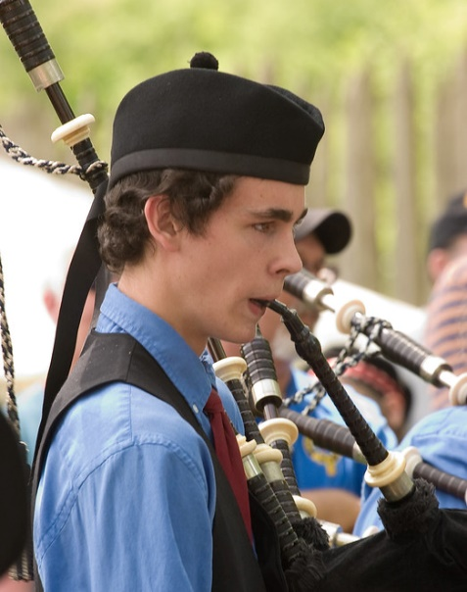
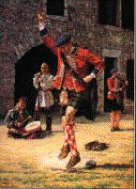

Application: Applicants must submit the following in letter form:
- Name, full mailing address, telephone number, email, and date of birth.
- Amount of desired scholarship.
- Description of the course or program the applicant intends to enroll in or follow and should include:
- Name and description of course or program.
- Name, address, email, and telephone number of school or instructor.
- Dates of planned enrollment in course or program.
- Course or program costs (instructional fees, materials, etc.).
- Description of applicant's past participation in Scottish-oriented activities and/or training.
- One written and signed reference letters from non-family members supporting the applicant's serious interest in and suitability for the contemplated course or program. The reference letter must include a phone number and email at which he/she can be reached and his/her position in any Scottish-related organization which they belong., if appropriate.
Timing: Scholarship requests may be submitted at any time during the year. Applicants will be informed in writing of approval or disapproval within three (3) months of the date of receipt.
Process: When received, an application will be reviewed by the Chapter Council for completeness. Since scholarship funds are limited, the Council will evaluate the application for appropriateness of the course or program and related merit of the request. If necessary, the Council may request additional information from either the applicant or the references.
After final evaluation by the Council, the Council will notify the applicant in writing of the Council's decision. The notification will include a bank check if the application is approved.
Address: Clan Gregor Society, Great Lakes Chapter
Joseph H. Greer, Chair
118 Braybarton Blvd.
Steubenville OH 43952-1123
740.275.4025

Revised 20 Aug 2019 JHG

