A Scottish Welcome!
Our Chapter’s purpose is to support our foundations in Scotland, to provide funding for scholarships in Scottish arts and traditions, to help develop a sense of kinship with each other, and to aid members who are tracing their ancestry. We invite your inquiries, welcome you to our events, urge you to send stories and join us in membership.
Brief History of Clan Gregor
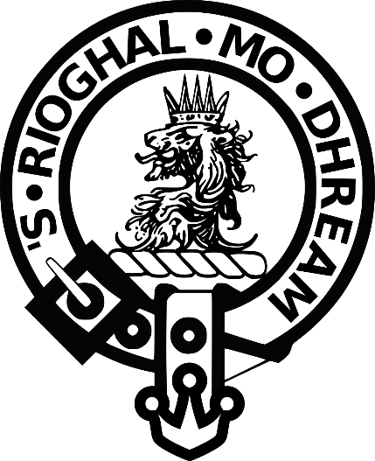
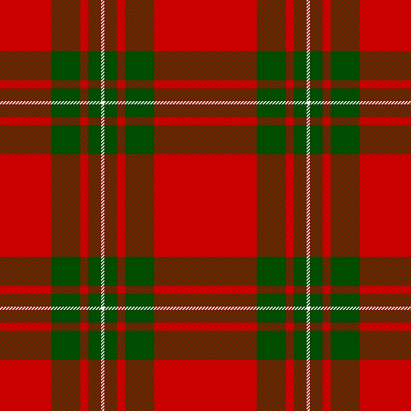
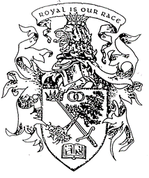
Clan Motto “Royal is my race” | MacGregor Tartan Modern | MacGregor Badge
Clan Gregor is one of the oldest Scottish Clans. Our land was held allodially (by right of first settlement and held by the sword), but over time was lost “by fair means and foul” to those who obtained Crown charters. As an indigenous clan with roots going well back into Bronze Age Scotland, the Clan stood by its ancient traditions, refusing to give up what lands they considered theirs. After centuries of repression, proscription, banishment, imprisonment, slavery, and death, the name of MacGregor was restored by the British Parliament in 1774.

Key Dates in History:
6000 BC First documented occupation of post Ice-Age Scotland’s west coast at Kilmartin. A mere 28 miles to the north at the top of Loch Awe are the ancient MacGregor lands of Glenorchy and Glenstrae. Food for thought…!
1318 Robert the Bruce gives our Loch Awe lands to the Campbells, despite our support for his cause at Bannockburn and at Dundalk in Ireland. We had been enemies previous to 1308 but in accepted feudal fashion, joined him after the battle at the Pass of Brander in that year.
1603 Alasdair MacGregor marches into Colquhoun territory at Glen Fruin with a force of 400 men in response to Colquhoun hanging two of the Chief’s kin. Against them were arrayed 500 troops and 300 mounted cavalry. In a strategic false retreat, the MacGregors kill about 200 Colquhouns for a loss of 2 MacGregors, one of whom was the Chief’s brother. The battle is considered a classic in clan conflicts, but in winning the battle we lose the war, when James VI declares the name of MacGregor as “altogidder abolished under pain of deid (death)”. The Proscription remains in effect for over 140 years, stating that anyone who bears the name must renounce it or suffer death.
In response to this battle, Alasdair MacGregor and eleven of his kin were hanged at the Mercat Cross, Edinburgh, with as many as 99 clansmen hung before it is all over. As a result, the Clan Gregor was scattered, adopted aliases, and became “children of the mist”. See the list of septs/surnames in our clan tent.
1689 The “Glorious Revolution”. Led by Bonnie Dundee, the clans rise against redcoat incursions into Scotland. At the battle of Killiecrankie their army is crushed by the Highlanders. Rob Roy is present at age 17 with his father, Col. Donald Glas McGregor leading a cohort. Robert Burns later pens a popular song about the conflict.
1707 The Union of the Crowns, engineered by Scottish and English noblemen.
1715-1716 The battle of Sheriffmuir is a failed rebellion by the Jacobites in an attempt to place Scottish James Stuart on the throne over Austrian-born George I.
1745 The last, and most famous of the Jacobite rebellions takes place at Culloden, near Inverness. In hindsight, it represents the final attempt to place Bonnie Prince Charlie, the Stuart heir, on the throne over George II. The MacGregor contingents carry out strategic operations in Ross and Cromarty as well as taking part in the charge.
1774 In London, the Proscription is abolished and the MacGregor name reinstated.
Geography
Clan Gregor held highland territory in Glen Orchy, Glenlochy, Glenstrae, Glen Lyon and Glengyle. This area is situated between Loch Lomond and Loch Awe in central Scotland.
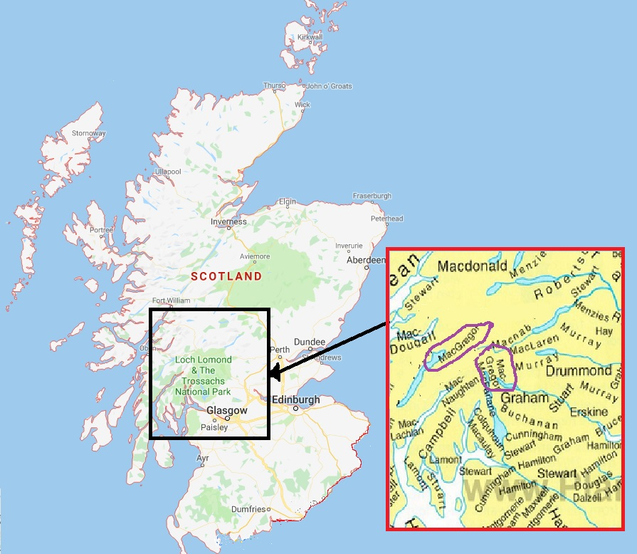

The Clan Gregor Society
The Clan Gregor Society of Scotland was formed in 1824, one of the earliest Clan Societies. It was managed by a committee of professional men, all surnamed MacGregor and living mainly in Edinburgh or Glasgow. The object was to give “the poor of the Clan the benefits of a sound and Christian Education.” To this end, large sums were subscribed and distributed which helped the re-establishment of the landless clansmen in Victorian times. Many young men from the glens of Perthshire and Argyll benefited.
The Great Lakes Chapter is one of five chapters in the U.S. Membership is open to all MacGregors, family, and friends. For more information, contact GLC Chair Joseph Greer at jgreer121@yahoo.com

