What happens at Scottish Highland Games & Festivals?
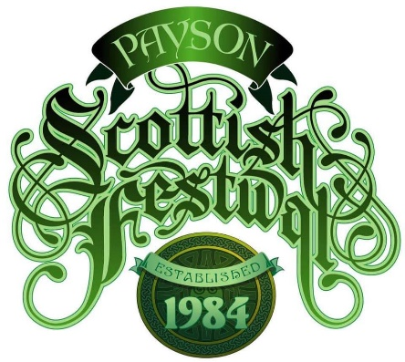
A local Scottish Highland Games & Festival is a celebration of Scottish heritage for a Saturday. You get immersed in Scottish culture for a day, absorbing heritage, outfits, music, food, and entertainment.
It encompasses a half day of sporting events for big fellows and fast runners, Celtic food vendors for lunch, Celtic arts and crafts vendors, Scottish kilt and outfit vendors, jewelry and accessories vendors, dancers and singers, formal bagpipers and drummers, UK vintage automobiles, Scottish dog breeds, a parade of clan members at 11:30 am, and at noon and 5 pm a gathering of pipers and drummers who march and play loudly in formation like the movies.
CLAN TENTS
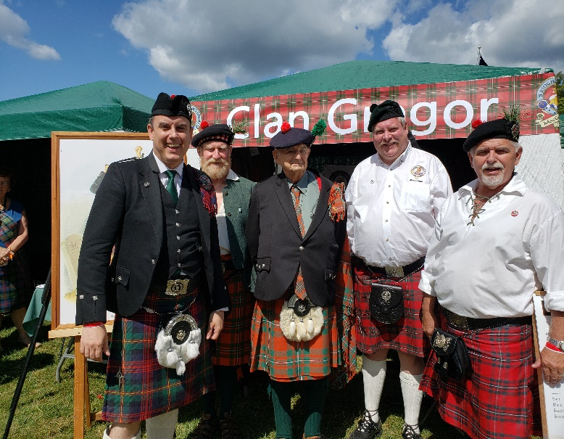
Between 20 and 50 Scottish “clans” each put up a 10 x 10-foot tent and advertise their heritage. Each family clan (e.g., Clan Gregor) has one or more unique plaid “tartans”. The men wear a plaid kilt and women wear a plaid sash or skirt, displaying their woolen tartan. Most clans have an ancestral castle or ruins in Scotland, located in the neighborhood where the clan historically lived. This was typically in a green glen between mountains. Each clan elects a “chief” in Scotland to be the symbolic head person. Each clan has stories of famous ancestors and their pursuits. Each clan has a family crest with a motto. Each clan had neighboring rivals too! Amazingly, there are more clan members in the USA than in Scotland, due to our large population
and historic migration from Scotland to North America. Visit and learn about your Scots ancestors!

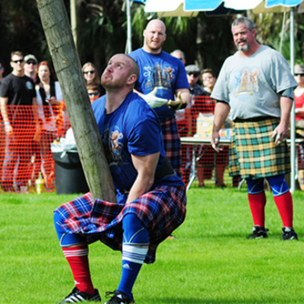
SPORTING EVENTS
The main feature of most Scottish festivals is the athletic “highland games”. There is a one- or five-mile running races with all contestants in kilts. There are contests of strength which involve shot-putting, throwing a stone block, throwing a hay bag up over a high-jump pole using a pitchfork, a team tug of war, and the iconic tossing to a huge wooden “caber” the size of a small telephone pole so that it bounces and falls straight forward. These participants appear to be right off an NFL football field!

KILTS & OUTFITS
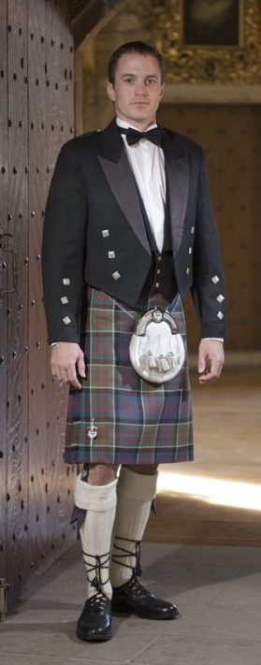
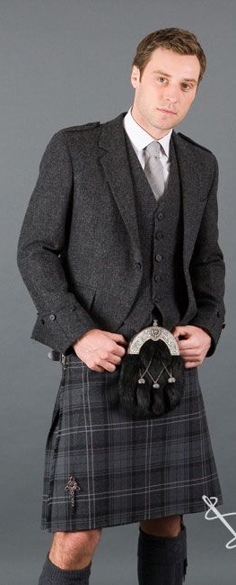
Apparel vendors come out in droves to these festivals. There are 3 levels of dress for Scottish men: casual with a kilt and long sleeve shirt, semi-formal with a regular tie and “Argyle” sport coat, and formal with a type of black “Prince Charlie” tuxedo with white shirt and bow tie. Colors of shirts and socks vary to coordinate with the colors in the plaid tartan. For women, there are lots of options with skirts, sashes, dresses, etc. Shoes are called “ghillie brogues” with long black laces that tie around the ankle.

JEWELRY & ACCESSORIES, ARTS & CRAFTS
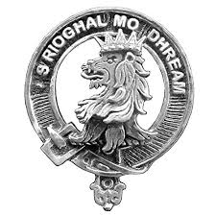
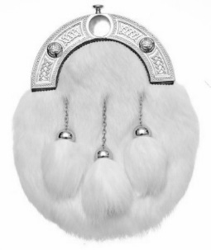
Jewelry and outfit accessory vendors are the most plentiful. Some are very casual “goth” outfit and armory vendors for re-enactors, while others are like department stores, some are for tourists, and some offer the semi-formal and formal kits. You can usually find several competing vendors for what you seek (e.g., ladies’ brooches). I have had fun acquiring one piece of the full Scottish outfit each year. For example, there is small sock knife called a “sgian dubh”, small fabric “flashes” for your socks, a man-purse called a “sporran”, clan badge pins to adorn a hat or to keep your kilt from flying open!

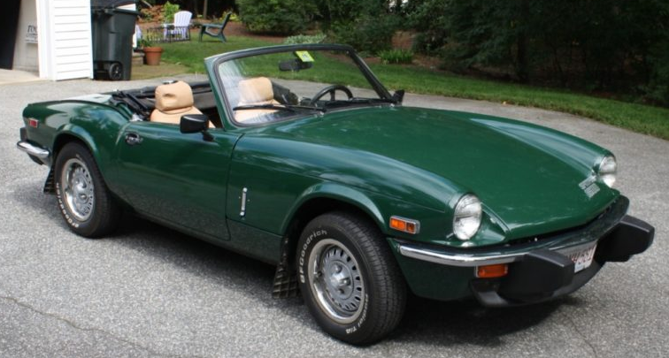
UK VINTAGE AUTOMOBILES
Many Scottish festivals display collections of vintage automobiles, often in racing green. You may see cars from MG, Triumph, Jaguar, Aston Martin, Land Rover, Bentley, and even an occasional Rolls Royce! All vacuumed and polished for fans. Geographically, Scotland lies just above England in the United Kingdom. Some automobile factories reside in Dublin

DANCERS & SINGERS
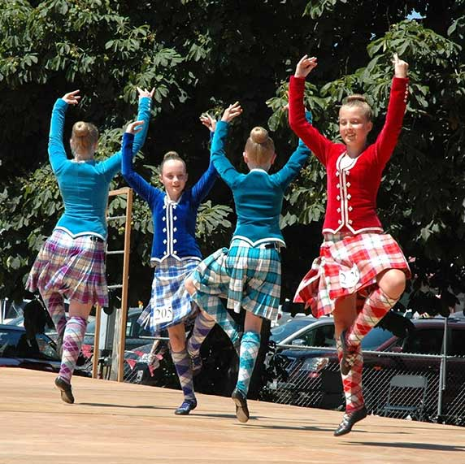
Various stages and tents are set aside for musical performers. Celtic singers with a guitar or smaller bands with drummers, bagpipers perform every half an hour. They usually sell music CD’s of their work. Chairs are set up for visitors to relax and listen. Some music is traditional ballad, some recent historical creations, and some current popular tunes.

SCOTTISH DOG BREEDS
Various breeds of dogs that you would commonly find in Scotland and the UK are often at the festival. They perform obedience training on a small stage. Otherwise they are relaxing with their owners on blankets and in crates for visitors to pet and discuss with owners. You may see large Collies, small Shelties, Labradors, Golden retrievers, tan & black Gordon setters, white Highland terriers, black Scottish terriers, Skye terriers, Cairn terriers, and a huge Irish Deerhounds.

PIPERS & DRUMMERS
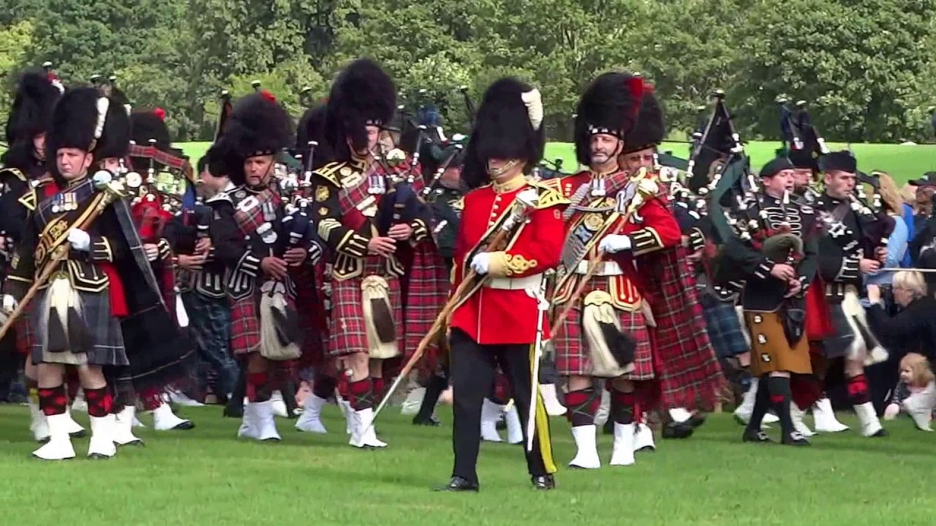
There are amateur and professional competitions for bagpipers and groups. Often the pipers are in a piping club or a professional Celtic band. They play traditional Scottish tunes, like “Amazing Grace”. There are usually impeccably dressed as well! Skilled judges review performances and have detailed grading sheets. Awards are given at different levels. Visitors wander around and observe and listen to the contestants.
CELTIC FOOD
There are always a few Celtic food truck vendors at the games. Scottish food usually consists of minced meat in a pastry. Remember, Scots are meat and potatoes people! You may see minced meat pies, sausage rolls, fish and chips, lamb stew, minced meat and onion bridies, sausage scotch eggs, and the iconic sheep innards “haggis” – an acquired taste. The popular non-alcoholic soft drink is named “Iron Bru” with an unusual flavor combination of orange and cotton candy! Try a variety of new foods.
